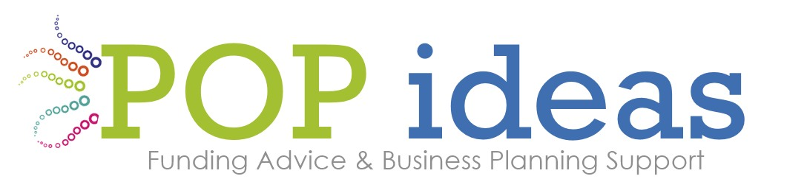

Writing a Funding Application: Headlines and Top Tips!
When writing a funding application always:
- look first at the funder’s specific eligibility criteria and their requirements - what they want to fund and activities/who they do and don’t fund
- take note of their language and key statements made in relation to their strategy, outcomes framework or specific goal areas
- look for ‘gateway criteria’ eg amount of reserves, geographical location, size of annual turnover or income; legal status (ie being a charity)
- check - does the funder require match funding?

There are many examples of small funding pots – here are three:
The National Lottery Community Fund has a rolling programme of Awards for All grants (£300 to £10 000). You can have one application in at any one time.
National Lottery Awards for All England | The National Lottery Community Fund (tnlcommunityfund.org.uk)
Plymouth Drake Foundation and links with Devon Community Foundation
Local funding pots in Plymouth - see this website for the latest available funding. Current campaign – supporting work for Children living in Poverty
http://www.plymouthdrakefoundation.co.uk/pages/grants/73
Applying for a grant - Devon Community Foundation (devoncf.com)
Always check the latest from The Arts Council England Covid-19 support | Arts Council England

TOP TIPS FROM A TEAM WITH FUNDING SUCCESS!
TOP TIP: With any funding bid, define your project before you start. Plan and prepare before you get going. Is it an on line application or a word document with structured questions, or a letter of application? It is always easier to create a word document and cut and paste from there.
TOP TIP: Stay within word count
TOP TIP: Always answer the question that is being asked
TOP TIP: Make sure your total budget comes within the grant size stated by the funder
TOP TIP: Create a unit cost to demonstrate that you are good value
TOP TIP: Research evidence of need
TOP TIP: Be clear about your beneficiary group
TOP TIP: For most funders there is a requirement for project activity, if this is the case then make sure your activity is project based – a specific piece of work, having clearly defined aims and objectives and delivered within an agreed timescale. The funder may be supporting capital investment or running (revenue) costs.
TOP TIP: It is important to be clear about the difference between your activities and your outcomes
An ACTIVITY is what you do
- Delivering workshops to community groups and in schools
- Creating a short film for educational purposes
- Working with hard to reach groups through delivery of taster sessions in three art forms
OUTCOMES are the changes that are made; the results; the difference that occurs because of your project/activity
- Increased access to cultural opportunities locally
- Reduced social isolation
- Increased confidence
- Better quality of life
- Improved work pathway
Funders want to hear your passion and your honesty and they want to believe that what you are saying you can do is really what you can do. Funders have variable decision making processes and sometimes these are explained and transparent, with a scoring framework and in other cases not publicised at all.
TOP TIP: Use Strong Language and be clear in your writing
We will create a clear and accessible…
Evidence tells us that…..
We want to pilot a tried and tested project activity with a new client group.
We believe that our greatest strength lies in the local community where we are based.
It is our robust and long lasting partnerships with six agencies, each with their own track record as listed below….
The groups we are targeting have previously been denied access through barriers that are created by…..
Our work is innovative, contemporary and stylish
TOP TIP: Make some reference to their language in your application (eg repeat back)
TOP TIP: Involve a secondary reader or person to critique and support you as you write your bid; this role is also to ensure there is flow and that it makes sense and meets the funder’s criteria
TOP TIP: Before submitting your application, make sure to have it proof read

Written by Susan Moores 2015; last updated 20/01/22

