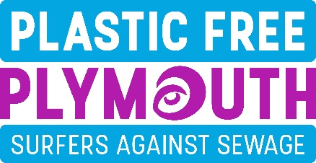
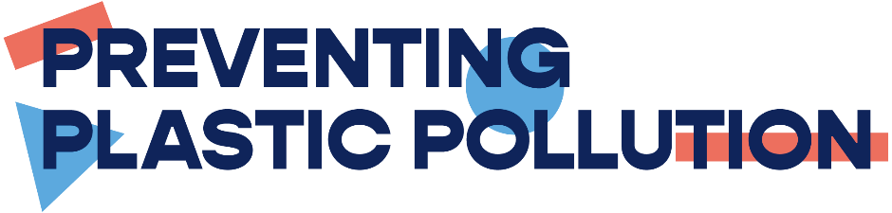

YOUR PLASTIC FREE PLEDGE

Our aim is to take action on plastics…….to tackle what is already damaging the environment and to reduce our need for it in future.
Make a start by making your pledge
Contact name :
Organisation or business :
Contact email :
Address and postcode :
(We accept that our email address will be retained for the purpose of communicating further information about the Plastic Free Plymouth campaign and its associated events and understand that we can request its removal at any point
Please tick.
Our initial commitment is to :
Remove, eliminate or replace the following three items from everyday use :
1.
2.
3.
In future we plan to address the following three items or challenges :
1.
2.
3.
Once you have done this please return your form to plasticfreeplymouthsound@gmail.com
We will then confirm your status as a Plymouth Pioneer (for businesses) or Ambassador (for Community groups and Individuals) or Champion (for Schools) and let you know what the next steps will be.
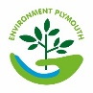
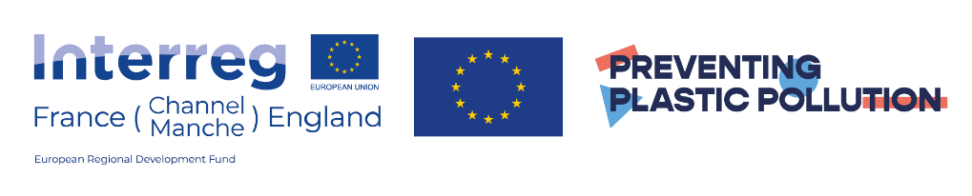
Thank you

