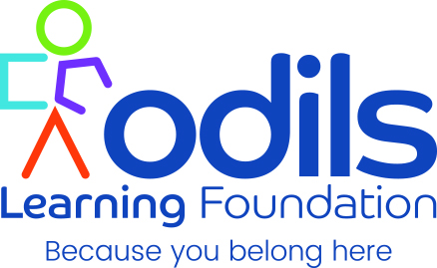
We are a faith based charity and started in 2001 in response to the needs of newly dispersed Asylum Seekers sent to Plymouth. We serve all communities with English as a second language, many of whom are from the Asylum and Refugee community.
Odils aims to:
To see people with English as a second language equipped with the skills and knowledge to belong and contribute to their community.
Leading to improved health and wellbeing and sustained economic wellbeing.
We do that through the teaching of formal and informal English Language, Employment and skill training and mentoring. Also partnering with locally based organisations through a Sport and Wellbeing group and a BAME Career Hub.
We are a British Council accredited language school and also hold public government and Local Authority contracts inspected by Ofsted.
You can find us at www.odils.com
28 Woodland Terrace Lane, Greenbank, Plymouth, PL4 8QL
01752 258770
ODILS Learning Foundation is a trading name of Open Doors International Language School
Charity number 1092728

