Plymouth workshop – May 2017

Background

Esmée Fairbairn trustees last year approved a pilot programme of place based funding – investing a sizeable amount in to specific areas with the intention of making our work there more than the sum of parts. Each grant will be £1m+ and look different depending on the area, in order to make best use of local assets and opportunities.

As a Sustainable Food City and Social Enterprise City, Plymouth connects to a number of our interests as a Foundation. These ‘badges’, along with feedback we’d heard as to the desire to work differently amongst both the voluntary and the public sector led us to scope the potential for a place based programme in the city. A visit in February gave us the opportunity to meet with representatives across the voluntary sector, Plymouth City Council and other funders. The overall impression was of a sector that spoke in terms of Plymouth rather than individual need, of a desire to collaborate and work differently, and of a refreshed energy in the sector, attributed by many to the backbone support provided by Plymouth Octopus Project (POP).

A potential structure for the Esmée funding was therefore proposed – funds to grow POP in order for it to meet the needs of the sector, as well as a locally owned pot of funding, designed to unblock systems and help make change and collaboration a reality. The workshop held in May was designed to test this idea – what did people want from both POP and the pot, what should be the ultimate goal of this initiative, and what were the guiding principles by which people felt this should be designed and governed by?

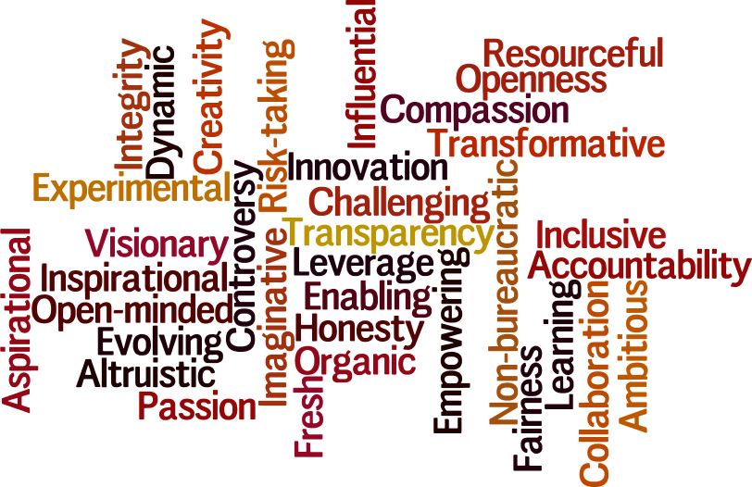
Values and characteristics

There was an overwhelming sense that the structure of the initiative should be kept as simple and inclusive as possible. There must be a mechanism for learning from both successes and failures, and decisions should be made openly and democratically. The funding pot needs to pull people together and create measurable change, rather than fostering unhealthy competition. This change must be sustainable, ensuring a more confident and connected sector is left at the end, rather than increasing dependency.

The funding pot – opportunities for Plymouth

The word ‘leverage’ was used repeatedly, with a feeling that funds should be used to bring in other money or to get things off the ground. There was a desire for it to be used to overcome problems or challenges, or to help manage change such as statutory shrinkage leading to increased referrals to small organisations. There is an opportunity to take risks and be forward thinking – to both seed fund interesting start up ideas but also help organisations be more enterprising and sustainable. The VCS should use the funding to be a leader not a follower.

Specific examples included a ‘City Challenge fund’, where city problems could be identified and work done to unblock the problem, using funding to support joint working for example. Funding could be used for research work on social issues identified, to ensure the problem is fully understood. It could also be used to support leadership and activists – finding the ‘doers’ and accelerating what they’re involved in. This includes young people, who will be the next generation of voluntary sector leaders.

Other practical suggestions included hosting big participatory events such as Big Buzz, and using funds for expenses and follow ups, supporting learning visits to other places, and providing pop up venues or shared resources such as printing.

Funding could also support links with Plymouth City Council (PCC) by funding time for individuals from the sector to act as a link, or support shadowing and secondments between voluntary, public and private sectors. A commissioners induction to the sector could also be developed, which could then be charged for in the future. IT and online learning could also be supported.

A quote that stands out is that “we can’t afford endless meetings”. These funds must be used for action – the will to collaborate and overcome challenges is there, but sometimes it can be hard to follow this up. Funds can support people’s time so that action is taken. Decision making on the allocation of the money must always be transparent and participatory. It should not be bureaucratic and should be flexible, with the freedom to do things differently. An example was given in another session of a group that got together a long time ago to look at the issue of street drinkers, but as so much time was spent talking beneficiaries may have been better served by just having the time spent on 121 work – some good off the wall ideas came out in conversation though, so what would have been the impact of having a pot of money to start playing with some of these and see if they could be made real?

What do people want from POP/PVCSE?

A theme had emerged previously of the role of POP as a ‘CVS for the 21st Century’. This question focussed on surfacing what people would want from an organisation of this type and what they would want, or trust, it to do for them. The main themes were:

- ‘A conductor for the orchestra’ – the sector is full of specialisms and knowledge, but someone needs to sit in the middle and draw it all together. This allows for spotting of gaps in delivery, of gaps in skills (tech given as an example), for making connections in order that collaboration can take place and just to have someone that knows what is going on. Sometimes a simple signposting is enough, but you need to know what is happening.
- A facilitator – sector want to ‘do’ things, but the seemingly simple things like arranging meetings, recording actions, following these up don’t happen when they’re no ones’ job. POP can fill this role though.
- Capacity building – supporting organisations to find suitable funding, bringing preparedness and professionalism to smaller organisations, providing training and mentoring to move organisations forward, and opening doors to all so that Plymouth is a not a ‘who you know’ type place. Support moving to tenders and commissioning, especially outcomes based, for suitable organisations is required, as well as potential for a Special Purpose Vehicle (SPV) to allow small organisations to join tenders. Ultimately POP should be a platform that everyone grows on, not an umbrella that people hide underneath.
  - Linked to this was the potential for shared back office support. A bank of policies and procedures was felt to be useful, as well as the provision of admin resources, printing, shared spaces and potentially a shared Plymouth VCS website, instead of everyone maintaining their own.
- Managing a relationship with PCC – there was recognition that it can be hard for a single organisation to challenge a local authority as they feel over exposed, but POP can speak with the collective voice of the sector, providing protection. They can act as the link between PCC and the sector and push the need for co-design and meeting the sector as equals. They can also manage expectations, which may at times mean talking down what the sector can do so that there is improved understanding of what is possible on reducing budgets.
- Big picture thinking – a role in both refocussing the sector on the bigger picture, energising, envisioning and celebrating the sector’s work, as well as doing some blue sky thinking and converting to actions for the VCS. A champion of the shared values of the sector, and someone to hold the long term vision when others are firefighting.
- Critical friend role – someone to challenge organisations on what they are achieving, play a mediator role in resolving conflicts between organisations, and someone to recognise when the sector needs to change. Someone to ‘hold the ring’, and challenge people when they aren’t acting collaboratively/in the sectors best interest.
- Communications and advocacy – communicating the value of the sector more broadly, manage the messages so that people see when change is happening, and amplify influence. Also act as a translator, for example by ‘de-fogging’ what happens at CCG meetings etc where the language is often impenetrable. Able to tell the story of the sector and champion learning, potentially through shared impact measurement.
In practice, people felt this meant several things. Firstly, this organisation must not be a ‘delivery’ body – that is the role of the sector and where conflicts arise. Trustees need to be kept fresh and term limits utilised. This feeds in to remaining accountable to members, so that it does not become a club, clique or cartel. In terms of structure it needs to be flexible, avoiding fixed overheads where possible. Ultimately it needs to have clarity of purpose as an organisation, and know where it fits amongst other networks and how it can best operate effectively. Whilst a lot of what is required of the organisation may be traditional infrastructure support, there is potential for a more activist role in some areas and the structure by which this is delivered is ripe for re-design.

Dreams and risks

We wanted to explore what the sector hoped the city would look like at the end of the initiative and what might stop it getting there. Overall, the aim is to see a more connected sector, that has a greater awareness of what is going on, that understands each other’s outcomes and as a result is able to engage better with others both within and outside Plymouth. There was a desire to be open and consultative – to take the best of what was happening outside the city and make it happen here, as well as telling a better story for Plymouth itself. Ultimately everyone who comes to the city should leave with a positive story to tell, and we all have a role in communicating that optimistic message. The potential of Plymouth’s population should be realised, by encouraging active citizenship and identifying leaders, especially more young people, whose new ideas find fertile ground in a city and sector that encourages mavericks.

Silos should be dismantled so that we are able to deliver the best possible service for Plymothians, even if that means your own organisations stepping aside. The power of a collective voice for the sector should be realised so that our views cannot be ignored, and so that powerful players (both within and outside the sector) are effectively held to account. Embracing the power of technology may be a part of this.

Key risks included a lack of engagement by key stakeholders, or more broadly a retreat to the bunker when further cuts come. The issue of over-cautiousness was identified, and the danger of preferring the theory to the practice. It is important that there is a way to measure success, but making sure this isn’t too reductive, for example an over focus on value for money. A lack of sustainability if the wrong type of work is funded was also identified. Overall there was a recognition that this funding represented a rare opportunity, so whilst it was important to identify risks in order to guard against them, the motivation exists to overcome them.

