Creating a Collective
- Log in to Open Collective
- Visit https://opencollective.com/create/community
- Fill in your information then click "Create Collective"
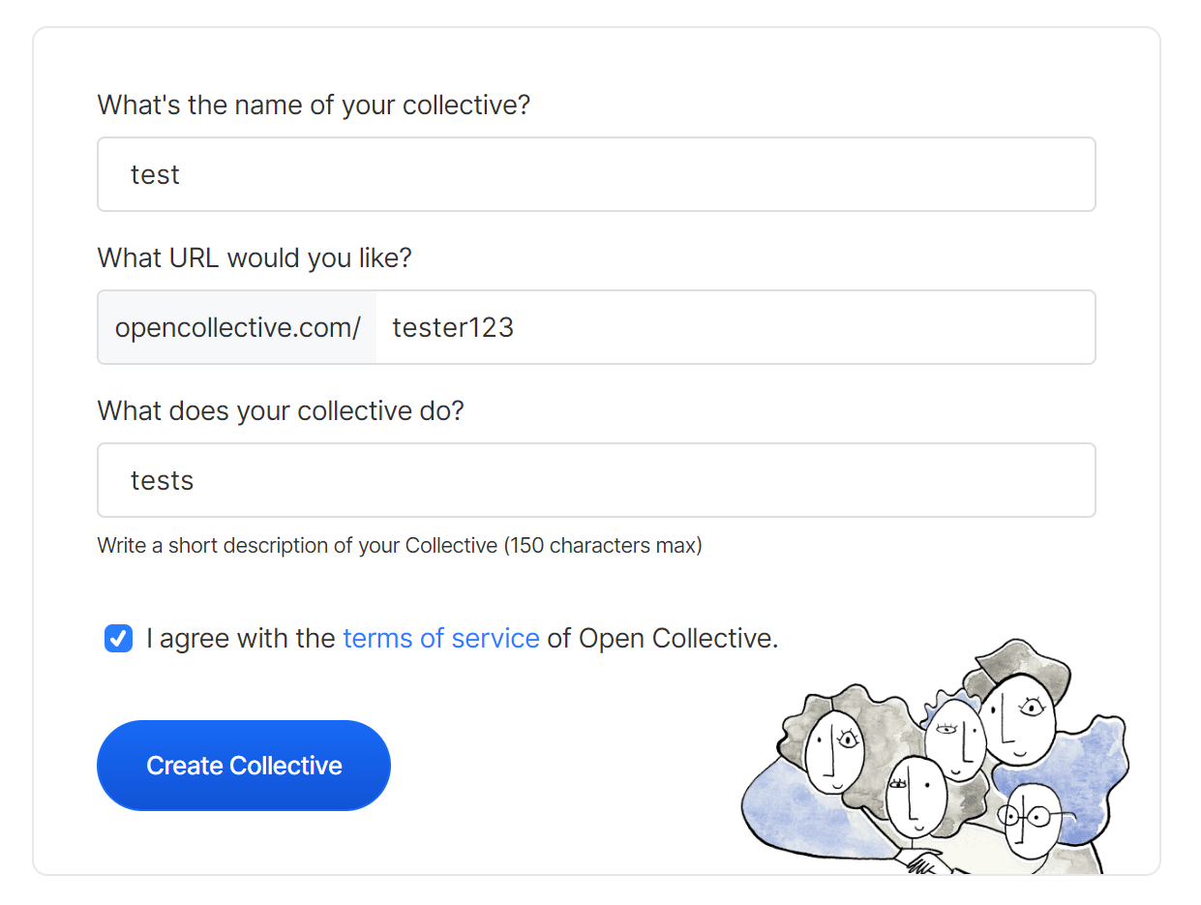
- Make note of your OpenCollective URL as it will be needed for your application form

